**CEDEFOP data analysis: Bulgaria**

**September 2019**

The CEDEFOP scraped five sources for Bulgaria for the period July 2018 – June 2019. One of them is an administrative source (National Employment Agency), one is general advertisements’ portal and three – are pure job portals. The BG_JOBS and BG_ZAPLATA are the two biggest job portals in Bulgaria. These two portals are scraped regularly by the BNSI also.

It is clear (see Table 1) that the data in the beginning is incomplete and probably testable (July – December 2018). Therefore, we prefer to make the conclusions in this report mainly for the period January - June 2019.

The biggest share of OJAs has BG_JOBS with 82.4%), then the second BG_ZAPLATA - 10.2%. The other three – have less than 8% share from total number of OJAs for the whole period.

*Table1: Total number of OJAs by job portals for the period July 2018 – June 2019*



The biggest number of jobs are announced in May 2019, which could be explained with the beginning of the summer touristic season and need for seasonal workers.

*Table 2: Daily OJAs for the month of May 2019 for BG_JOBS and BG_ZAPLATA*



The table 2 shows that for two job portals in May 2019, the BNSI scraped around 28% more OJAs than CEDEFOP. All home data are de-duplicated by the following variables: publish_date, employer, populated place, country, job_title. But we don’t know how the CEDEFOP data was de-duplicated. The difference could be explained that CEDEFOP did not scrape for some days during the mount May 2019.

In the table 3 for June 2019, the difference becomes even more – 41%. We can assume, that the BNSI uses better scraper or the CEDEFOP cleans and de-duplicate data in better way.

*Table 3: Daily OJAs for the month of June 2019 for BG_JOBS and BG_ZAPLATA*



*Table 4: OJAs by administrative regions (NUTS 2) and ESCO_level1 for the period for the period July 2018 – June 2019 (average values of daily OJAs)*



As we expected, almost half of OJAs – 47% are in the Yugozapaden region, where the capital Sofia is. In addition, 62% from total manager’s positions are announced in the Yugozapaden region. The OJAs for professionals, technicians and associate professionals and clerical support workers are also more than 50% from total number in the capital region.

*Table 5: OJAs by administrative regions (NUTS 2) and by category economic sectors for the* period *July 2018 – June 2019*



It seems that Bulgarian economy based on services as 84, 5 % from all OJVs for the whole period are in that economic sector. The small number of ads in agriculture sector could be explained through the manner that job vacancies are announced - most likely locally, from mouth to mouth, without the use of online job portals.

*Figure 1: Total amount of OJAs by salary and ESCO level 1 for the whole period (CEDEFOP data)*

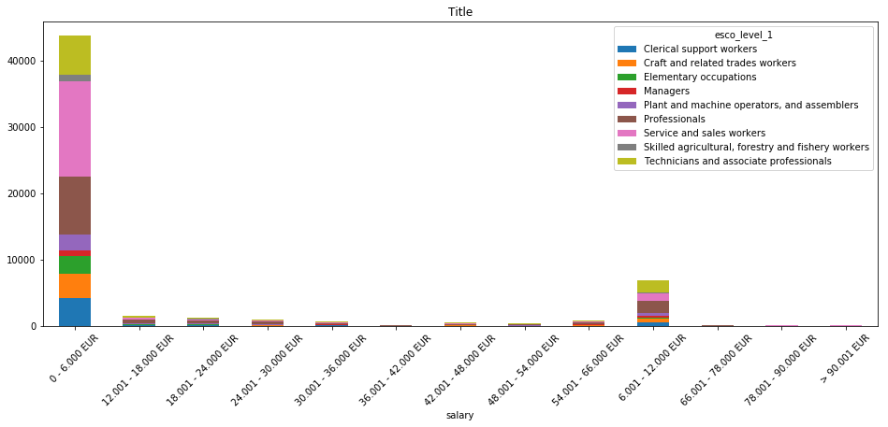

Figure 1 shows that most OJAs offer up to € 6,000 annual salary. In this income group, the professions sought are mainly in the service and sales workers group and professionals group according to ESCO level 1 classification. All other cases distributed in higher pay scales are almost insignificant, which is an indicator of the low cost of labor in Bulgaria.

In CEDEFOP data, there is a lack of information about the employer and thus it is not possible to determine from which economic sector the demand for a profession is coming. This would also be a constrain for correctly comparison with JV survey data.

For the project’s purposes, the BNSI obtained training data set from the National Employment Agency. The received data are for the period May-July 2019 and were compared to CEDEFOP and home scraped data. Unfortunately, the comparison makes a huge difference between the three datasets - e.g. by the Employment Agency for May and June 2019, 2 175 OJAs were announced with 6 310 OJVs, but CEDEFOP data shows that only 488 OJAs were scraped from administrative source over the same period (if we assumed that the BG_Administrative source is the National Employment Agency). Since the difference is almost 5 times, it cannot be explained only by the difference between OJV and OJA concepts.

The first comparison shows that although highly structured, the data from National Employment Agency are not correctly comparable for following main reasons:

* The basic concept is a job vacancy (Employment Agency), not job advertisement;
* These are just the JVs that employers voluntarily submit to the Employment Agency. In the Bulgarian reality, employers prefer to advertise their job vacancies mostly in online job portals, as it is faster and more convenient for them;
* From the moment when a job vacancy is declared in the Regional Labor Office until its actual publication on the Employment Agency's Internet portal, there is a certain lag of time, i.e. we can't say that these JVs are actual in real time.